**Chapter 1: Introduction**

The Multi-Granularity Citizen Science Platform (MG-CSP) represents a significant advancement in the domain of participatory research infrastructure, exemplifying a robust intersection of user-centered design, open science philosophy, and decentralized information systems. Conceived by a cohort of five final-year Management Information Systems (MIS) students, MG-CSP functions as a statically-generated web application engineered for collaborative scientific workflows. Its fundamental aim is to serve as a decentralized digital commons, enhancing archival integrity, fostering transparency, and enabling version-aware scientific collaboration without reliance on traditional back-end architectures. Aligned with the FAIR (Findable, Accessible, Interoperable, and Reusable) principles (Wilkinson et al., 2016), MG-CSP embodies the core tenets of scientific reproducibility and data sovereignty.

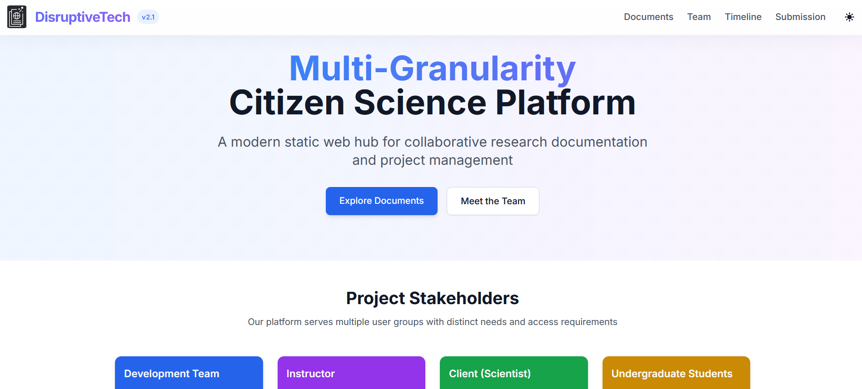

**Chapter 2: Strategic Objectives, Stakeholder Engagement, and Design Ethos**

2.1 Strategic Objectives

MG-CSP is strategically designed to deconstruct centralized bottlenecks by embracing a static-site paradigm. By employing HTML5, PDF, and JPG formats with modular repositories, the platform ensures that research data and documentation remain independently accessible and persistent. This design aligns with principles from the field of software architecture that emphasize separation of concerns, minimal server dependency, and information decentralization.

2.2 Stakeholder Taxonomy and Role Modelling

The Onion Stakeholder Model (Sharp et al., 2007) was applied to categorize participants into three concentric layers: core actors (client scientists and student researchers), support actors (MIS instructors and peer reviewers), and contextual actors (external institutions and research consortia). Complementary to this, the Role-Goal-Task (RGT) analysis facilitated the mapping of stakeholder objectives to interface components, optimizing the UX architecture for both novice and expert users. Personas and use-case narratives were developed through contextual inquiry and ethnographic interviews, aligning with participatory design methodologies.

**Chapter 3: Information Architecture and Web Taxonomy**

3.1 Hierarchical and Semantic Design Model

Guided by Rosenfeld and Morville’s (2015) IA principles, the platform utilizes a hierarchical, semantically rich navigation system. A persistent sticky navbar provides zero-friction access to essential sections, while dynamically generated Call-to-Action (CTA) hero panels adapt to user interaction patterns. Footers include structured metadata using Dublin Core and ORCID, facilitating citation and authorship interoperability across academic ecosystems.

3.2 Modular Document Ecosystem

The site structure embodies modular decomposition through the following:

* **Dashboard Interface**: Segregated by discipline, lifecycle stage, and contributor role.
* **Design Section**: Encompassing stakeholder models, personas, HTA schemas.
* **Interactive Document Repository**: Integrating PDF.js for inline rendering and semantic indexing.
* **Governance Space**: Archival interface for meeting minutes, contracts, and role-based histories.

This model not only supports version control and peer review but also ensures provenance and traceability.

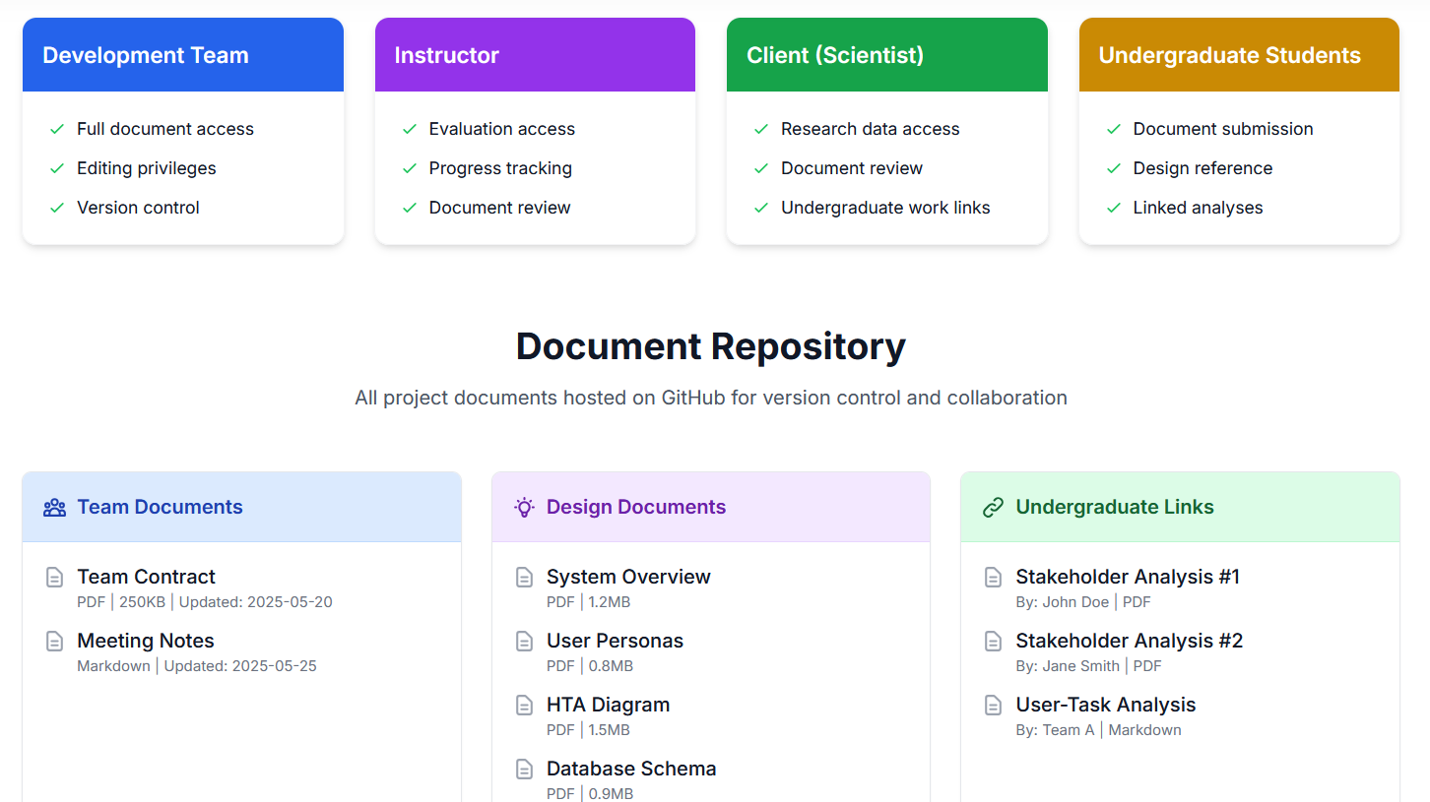

**Chapter 4: User Experience and Human-Computer Interaction**

4.1 Cognitive Ergonomics and Flow Optimization

MG-CSP employs the Universal Principles of Design (Lidwell et al., 2010) to construct an interface that supports uninterrupted cognitive flow. The system applies a color ontology where UI cues adhere to universal affordance mappings (e.g., red = error, green = confirm). Fonts like Roboto and Inter optimize typographic legibility, while CSS Grid and Flexbox frameworks assure logical flow across devices.

4.2 Device Responsiveness and Accessibility

Marcotte’s (2011) mobile-first responsive design was implemented with ARIA/WAI-ARIA roles, touch-optimized CTAs, and adherence to WCAG 2.1 standards. Accessibility measures include screen-reader-friendly labeling, skip links, and a minimum contrast ratio of 4.5:1, ensuring an inclusive digital environment.

**Chapter 5: Collaborative Workflows and Knowledge Engineering**

5.1 Collaboration Engineering

Embedded collaboration tools follow cognitive walkthrough frameworks, employing Hierarchical Task Analysis (HTA) for decomposing scientific workflows. Personas and scenarios are generated through participatory methods, enabling inclusivity in design and outcome expectations.

5.2 Modular Contributions and Review

The platform supports modular content contributions indexed by document type and author role. This facilitates granular peer review and structured academic scaffolding. Contributions are version-controlled with ISO 8601 timestamping, providing immutability and archival fidelity.

5.3 Advanced Search and Discovery

Semantic document discovery is powered by faceted search (Hearst, 2009) and enhanced through Schema.org microdata. These mechanisms support advanced filtering by metadata dimensions such as author, discipline, and date of submission.

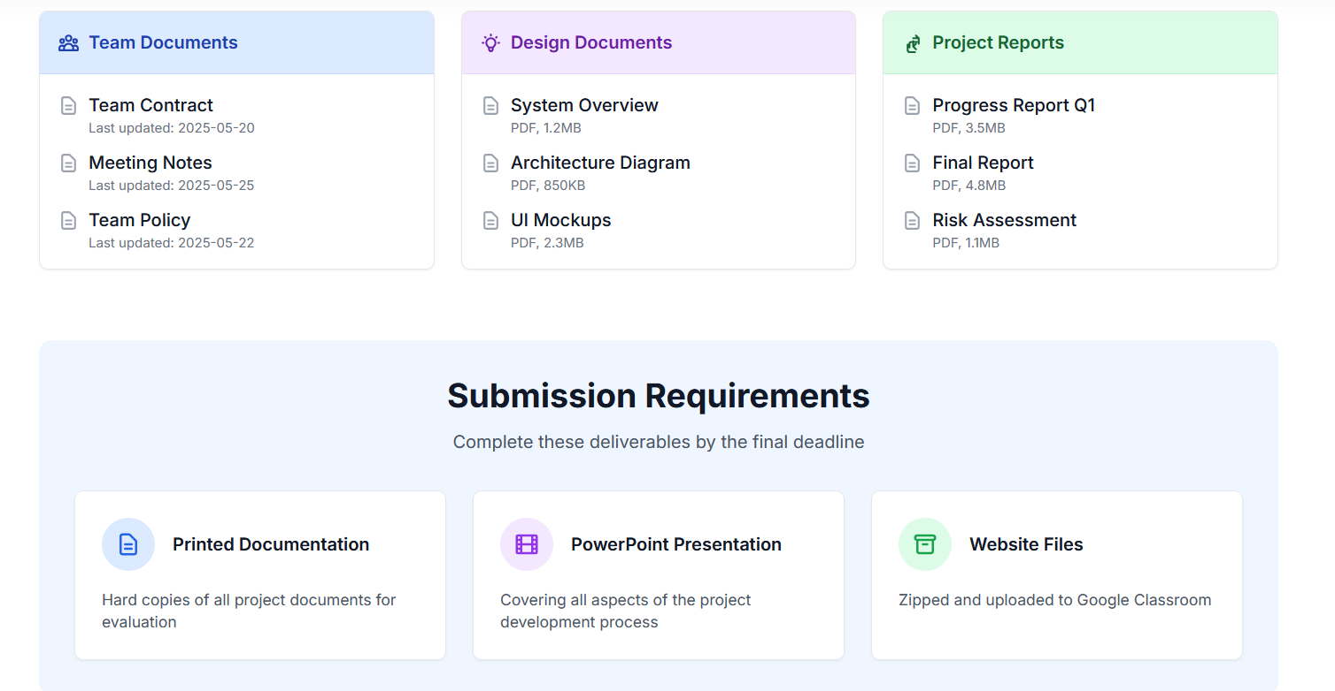

**Chapter 6: Technical Architecture and Implementation**

6.1 Static Site Generation and Toolchain

MG-CSP is implemented using Eleventy (11ty), a JavaScript-based static site generator. Supplementary modules include PDF.js for inline document rendering and Algolia for client-side search, ensuring rapid load times and seamless interactivity without server-side dependencies.

6.2 Performance Optimization

Performance engineering follows best practices from Grigorik (2013), including:

* **Critical CSS Inlining** for faster first paint.
* **Lazy Loading** images using attributes.
* **Service Worker Caching** to allow partial offline access, consistent with Progressive Web App (PWA) standards.

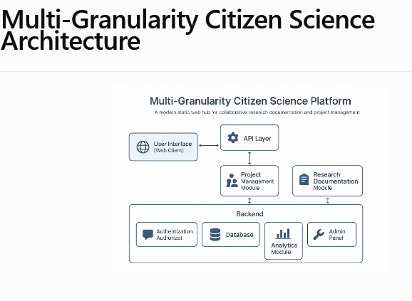

6.3 Security and Privacy Compliance

The platform employs GDPR-compliant analytics via Plausible, ensuring anonymized user behavior tracking. OAuth 2.0 authentication secures role-based access, and an Ethical Use Policy discloses data retention and cookie usage transparently.

**Chapter 7: Adaptive Theming and Accessibility UX**

7.1 Dark Mode and Inclusive Design

The platform automatically adapts themes based on OS-level user preferences using the prefers-color-scheme media query. Following Google’s Material Design Dark Theme Guidelines (2020), the UI ensures perceptual inclusivity by avoiding problematic color combinations (e.g., red-green pairings).

**Chapter 8: Governance, Provenance, and Trust**

8.1 Governance Architecture

Governance is embedded into the platform via:

* **ORCID Integration** to authenticate contributor identities.
* **Public Changelog and Roadmap** for transparency.
* **Digitally Signed Meeting Logs** to establish provenance and accountability.

These features establish an audit-friendly environment, crucial for pedagogical evaluation and long-term system credibility.

**Chapter 9: Evaluation Protocols and Deliverables**

9.1 Submission and Validation Framework

Artifacts are submitted in version-controlled .zip files with SHA-256 content hashes. Deployment-ready HTML is validated using W3C and Lighthouse standards, ensuring compliance with modern web practices.

9.2 Feedback and Iterative Improvement

Usability testing incorporates A/B testing insights, stakeholder walkthroughs, and heuristic evaluations based on Nielsen’s (2006) 10 Usability Heuristics. Presentations include stakeholder alignment matrices, user journey maps, and detailed health technology assessment (HTA) models.

**Chapter 10: Conceptual Schema Design and Future Integration**

While MG-CSP is currently a static application, it is engineered for seamless transition to a full-stack environment using Grails and GORM. The proposed domain model includes entities such as Mission, Incident, and Incident_Photo, supporting federated real-time collaboration and advanced data analytics.

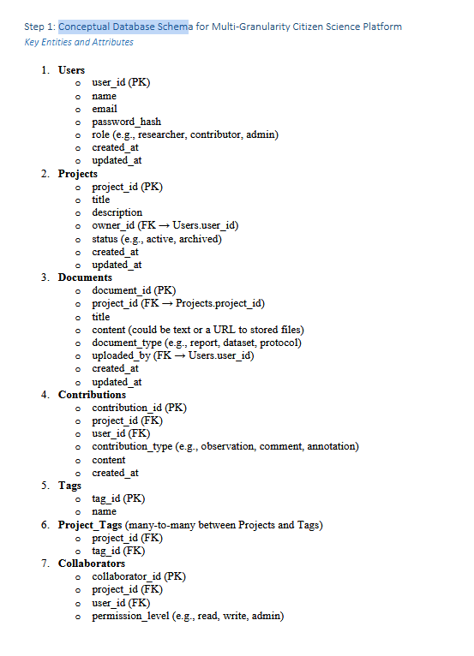

Conceptual schema

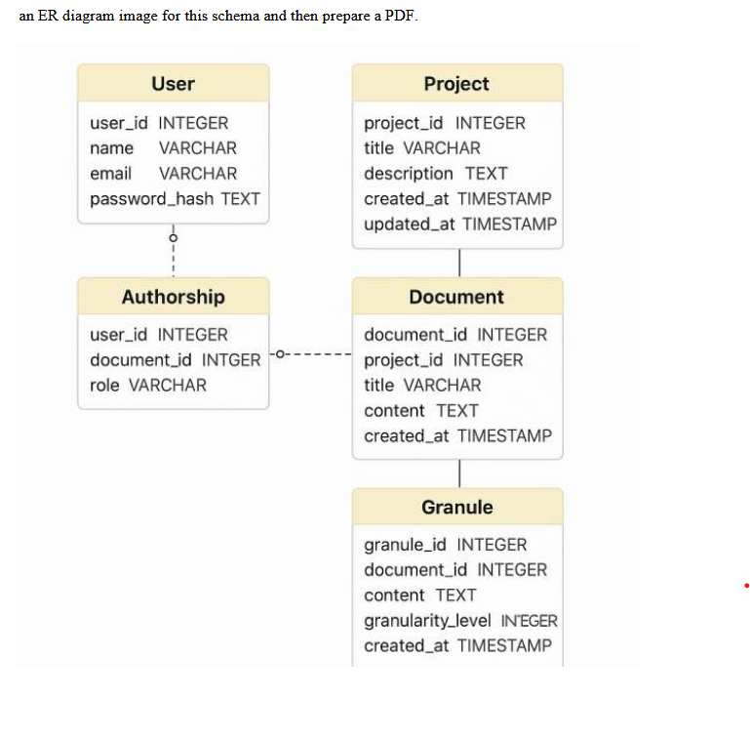

**Chapter 11: Conclusion and Forward Trajectory**

MG-CSP serves as a technologically resilient, pedagogically grounded, and ethically aware research infrastructure. It offers a blueprint for citizen science platforms aiming to balance transparency, decentralization, and usability. Proposed enhancements include:

* AI-driven contribution matching using NLP techniques.
* Blockchain-enabled provenance for immutable document verification.
* API integrations with Moodle, GitHub, and open science toolkits.

**References**

* Rosenfeld, L., & Morville, P. (2015). *Information Architecture for the Web and Beyond*. O’Reilly.
* Lidwell, W., Holden, K., & Butler, J. (2010). *Universal Principles of Design*. Rockport.
* Hearst, M. (2009). *Search User Interfaces*. Cambridge University Press.
* Grigorik, I. (2013). *High Performance Browser Networking*. O’Reilly.
* Marcotte, E. (2011). *Responsive Web Design*. A Book Apart.
* Sharp, H., Rogers, Y., & Preece, J. (2007). *Interaction Design*. Wiley.
* Nielsen, J. (2006). *Ten Usability Heuristics*. NN Group.
* Wilkinson, M.D. et al. (2016). *The FAIR Guiding Principles*. *Scientific Data*.
* Google (2020). *Material Design Dark Theme Guidelines*.
* Enge, E., Spencer, S., Fishkin, R., & Stricchiola, J. (2015). *The Art of SEO*. O’Reilly.